**Lab Task 2**

**My Application: Simple Text with Text and Image**

**Objective:**

* Using text and image object

**Fields**

Fields allow you to display text in your application. You can also use fields to allow the user to enter and edit text or make selections.

Fields support multiple fonts, styles and colors.

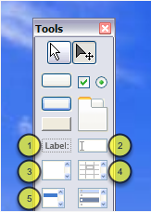

There are 5 basic field types in LiveCode, all of which you can add to your stack from the Tools Palette.

1. Label field: a single line, non-editable field

2. Text entry field: a single line, editable field

3. Scrolling field: a multiline, scrollable, editable field

4. Basic table field: a basic table field allowing data to be displayed in cells

5. Scrolling list field: a multiline, scrollable, non-editable field allowing the user to make single or multiple selections

All these objects are really the same type, they are just templates with different properties set to give different appearance and behavior. For example you could add a basic text entry field to your stack and by setting the appropriate properties turn it into a scrolling list field.

1. Create new stack
2. Create a field object

Choose one of the field that you think suitable for displaying message. Drag the field object and put onto the stack.

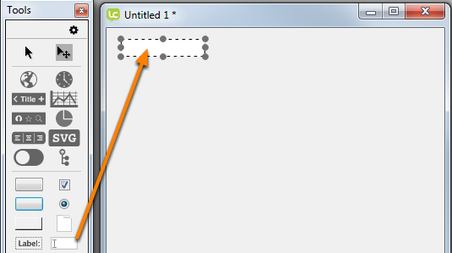

Type "Welcome to LiveCode" into the field using Object Inspector -> Contents. Rename the field as “Title”.

1. Edit field formatting

Edit the text formatting as following:

* Alignment: Center
* Font Type: Calibri
* Font Color: Red
* Font Size: 16

1. Repeat step 2 and 3

Add a short description about LiveCode as following:

LiveCode is a truly multi-platform programming tool with iOS, Android, Mac, Windows, Linux, Server & HTML5 deployment options. LiveCode uses a high level, English-like programming language called Transcript that is dynamically typed.

Rename the field as “Description”. Edit the text formatting.

1. Add an image to the stack.

To import an image choose File - > Import as Contol -> Image file and select the image. Once the image is imported, it can be moved and resized.

|  |  |
| --- | --- |
|  |  |

1. Save your stack

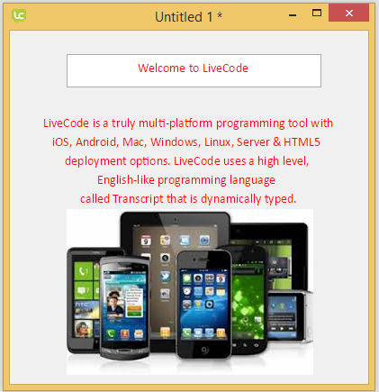

**You may also able to create image using Paint Tools. How to create an image using Paint Tools?**

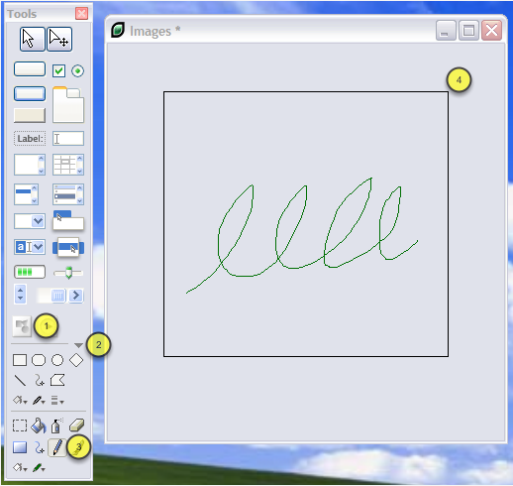

1. Add an image area to the stack.

2. Ensure the paint tools are shown in the Tools Palette by clicking the fold out triangle.

3. Select one of the paint tools.

4. The paint tool can be used within the image area.

**Tutorial Question:**

1. Edit your program by creating image using Paint Tools. Then, put some description about the image using field object. Use your own creativity in designing the work.